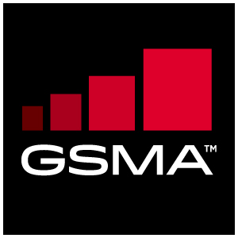 |  | TSG Doc xx_xx  AI Mobile Device Requirements Specification
Meeting Information
Meeting Name and Number |  | TSGAI#26
Date |  | 2022.03.30
Location |  | e-meeting
Document Information
Document Author(s) |  | Qualcomm Incorporate.
Document Creation Date |  | 23 March 2022
 |  | Approval | X
This document is for: (mark X as appropriate) |  | Discussion
 |  | Information only
Security Classification
Confidential |  | GSMA Full, Associate & Rapporteur members | X
Document Summary
This CR proposes to change the formatting of the requirement in section 3.3

Document History
Date | Version | Author / Comments

© GSMA 2017. The GSM Association (“Association”) makes no representation, warranty or undertaking (express or implied) with respect to and does not accept any responsibility for, and disclaims liability for the accuracy or completeness or timeliness of the information contained in this document. The information contained in this document may be subject to change without prior notice. This document has been classified according to the GSMA Document Confidentiality Policy. GSMA meetings are conducted in full compliance with the GSMA Antitrust Policy.

Performance
The device may use a benchmark system such as MLPERF.org, AI-benchmark.com, AIT China Telecom etc. to generate an inferencing performance report.
TS47_3.3_REQ_001 | The device SHALL use a benchmark system to generate an inferencing performance report.

